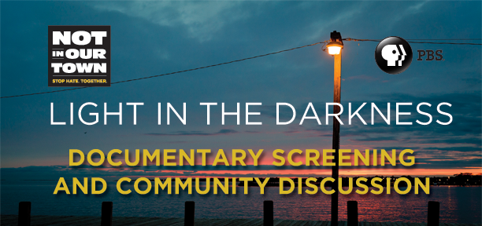
How can we stand together
against hate in our town?
Join us for a screening of Not In Our Town: Light in the Darkness,
a one-hour PBS documentary about a town taking action
after anti-immigrant violence devastates their community.
Date:
Time:
Location:
Contact:
Sponsors:
To learn more about Light in the Darkness and Not In Our Town,
visit www.NIOT.org or PBS.org/NIOT.
Not In Our Town: Light in the Darkness airs on PBS nationwide on September 21, 2011.
Check local listings.

